# Director’s Innovation Award Renewal Application

The aim of this project is to develop and evaluate surgical instrumentation for transcanal endoscopic ear surgery (TEES). TEES is a new and growing minimally invasive technique that allows the surgeon to perform middle ear surgery and send pediatric patients home the same day, as the surgery is done through the ear canal, eliminating the need of an external incision. SickKids is one of the few centres in North America where a surgeon completes the majority of middle ear procedures using TEES. The principle challenge with TEES is that it requires a one-handed surgical technique as the endoscope is held by the other hand. Current instruments have been designed for the two-handed traditional microscopic invasive surgical technique. This project aims to design a new instrument that would address the challenges faced by endoscopic ear surgeons.

Phase 1: Understanding the Needs of Endoscopic Ear Surgeons and conducting a Time Flow Study

An online needs analysis questionnaire was developed and sent to endoscopic ear surgeons internationally, after approval from the SickKids Research Ethics Board. Surgeons were asked to indicate their need for a new instrument to address eight different challenges experienced during TEES and comment on what new instrumentation they would like to see developed. Thus far, 22 surgeons have responded and the surgical difficulty of “reaching structures visualized by the endoscope” scored an average of 83% ± 4% need for new instrumentation. ANOVA with a 95% confidence interval showed that there was no significant effect of TEES experience on the difficulty experienced. A clinical research paper has been drafted and will be submitted to an otolaryngological clinical journal.

As well, a time flow study, where I recorded the duration of surgical steps during TEES was conducted with REB approval. This non-interventional observational study involved patient and surgeon participants. The goal of this study is to measure the efficiency of surgical steps, count the number of instrument switches to facilitate the step and understand what steps require better instrumentation and what functionalities those instruments should exhibit. So far, out of dissecting the skin off of the ear canal to access the middle ear space has the highest median time of 23 minutes. This study will also be submitted to an otolaryngological clinical journal.

The REB application, including patient and surgeon consent forms, research protocol, questionnaire, underwent a scientific and ethics review and was approved in March, 2017.

Phase 2: Development and Presentation of a Prototype Instrument

A prototype (shown below) was manufactured at the lab using Solidworks, 3D printing, a micro-milling machine and assembly of components purchased from McMaster Carr. This instrument has a flexible tip that can bend in one degree of freedom, controlled by the black “thumb piece”. This prototype was presented in a

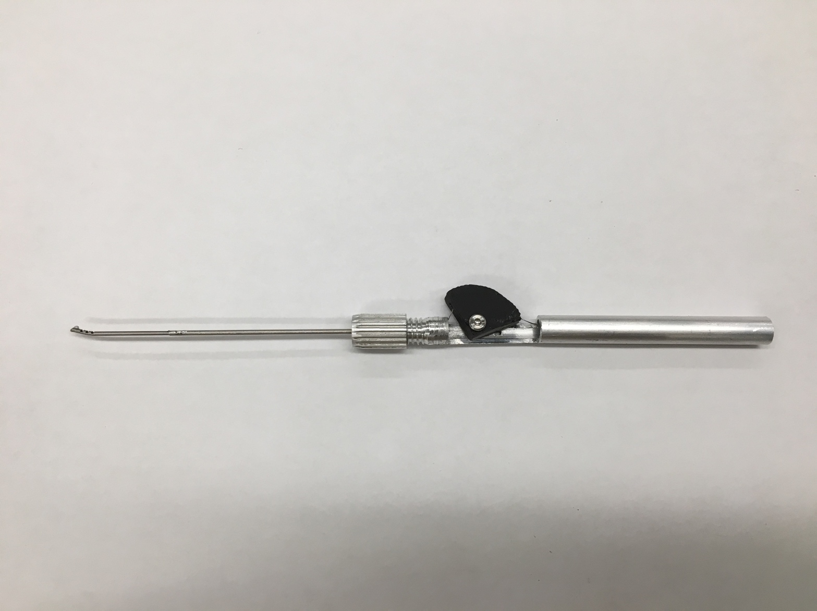

Phase 3: Refining the Prototype Using Patient Anatomical Data